**Twitter Data Analysis**

**Venkata Naga Satya Sangeeta Eluri**

**vxe160230**

**1(a) What are the hashtags tweeted and how many times are they used?**

Initially, we create a table in hive – named “json_tweet” and load “Tweets.json” file in to it.



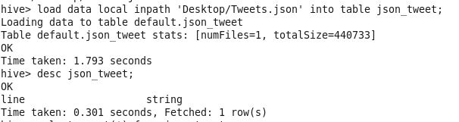

**Steps:**

1. Extract “text” from tweets data into a table called – “twitter_text”

**Creation:**

***Create table twitter_text as select get_json_object(line,’$.text’) as text from json_tweet;***



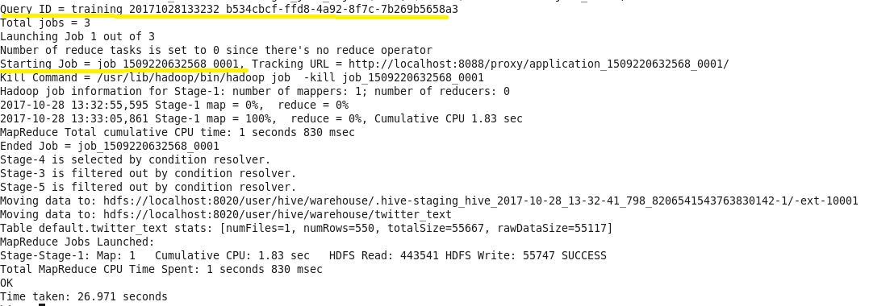

**Output:**

***Select * from twitter_text;***

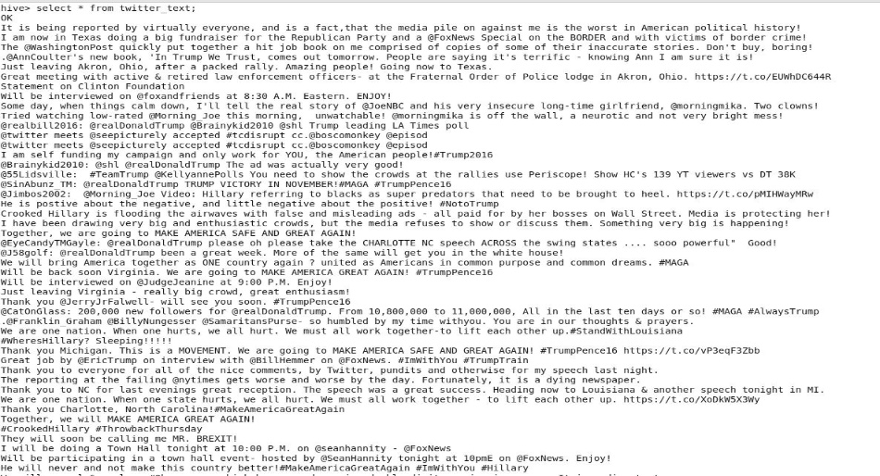

2. Split “text” into words – stored in table name “twitter_text_words”

***Create table twitter_text_words as select explode(split(text,’ ‘)) as words from twitter_text;***

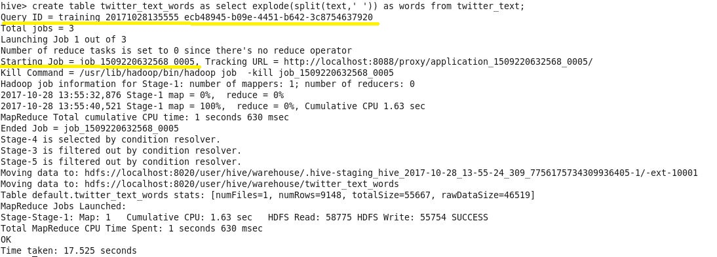

3. Retrieve all words that have hashtags – stored in table “hashtags”

***Create table hashtags as select * from twitter_text_words where words RLIKE ‘^#’;***

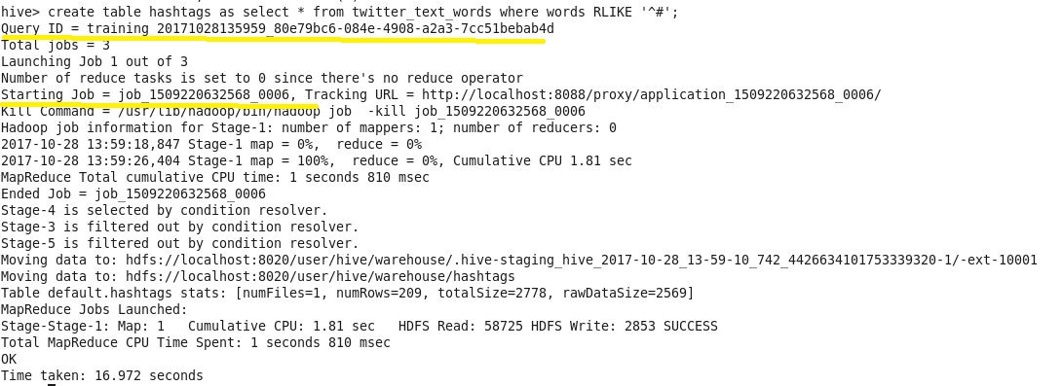

4. However, the result of table “hashtags” has got a few words with #tags without a space. Therefore, we need to split these words further by ‘#’ to get all of the hashtaged words and store in table – “hashtags_split”. Find screenshot **below.**

***Select * from result_1A;***

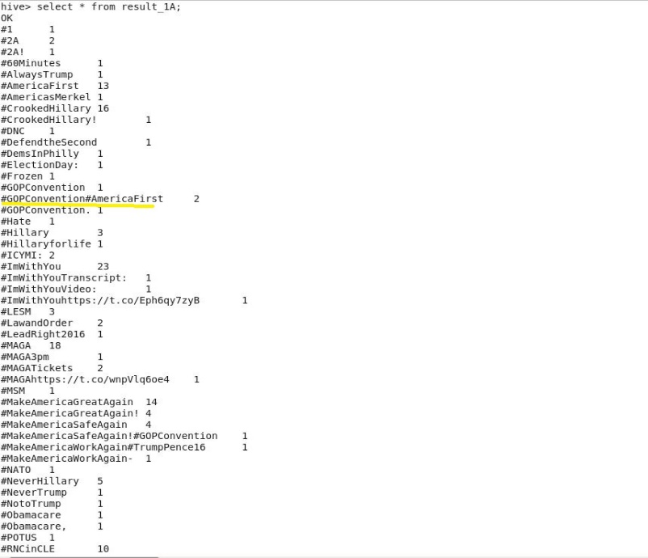

**Table creation with required words :**

***Create table hashtags_split as select explode(split(words,’#’)) as words from hashtags;***

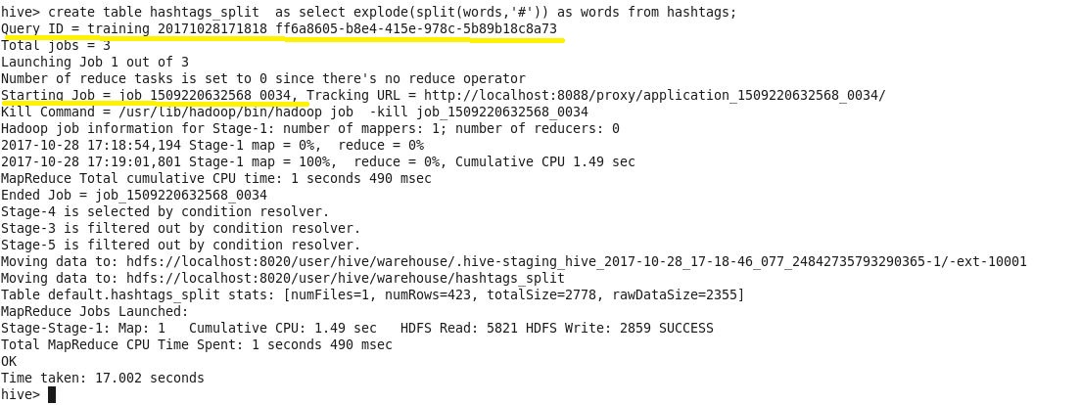

5. **Result** – hashtags with respective counts are stored in “result_1A” table:

**Creation:**

***Create table result_1A as select words,count(*) as count from hashtags_split where length(words)>0 group by words;***

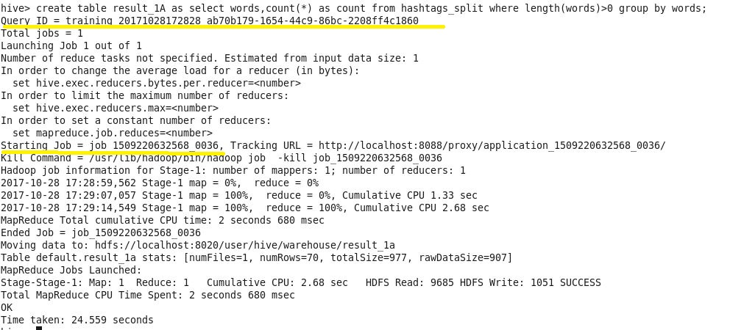

**Output:**

***Select * from result_1A;***

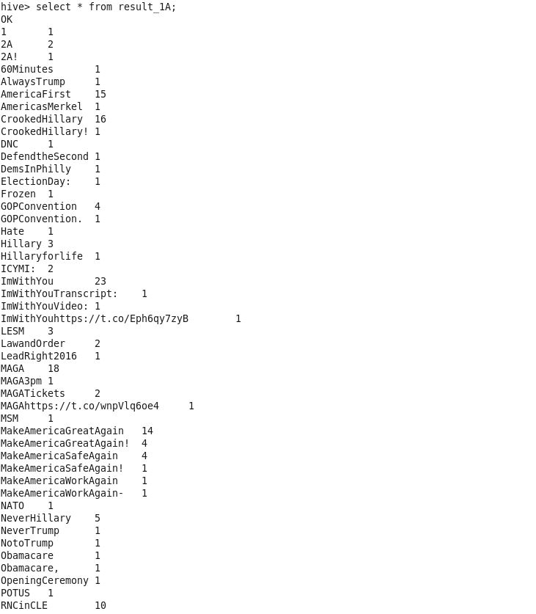

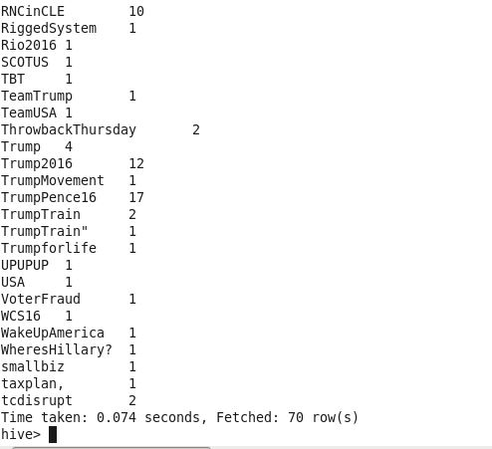

**Table creation with required fileds for use in following questions.**

**---** Table creation – “twitter_data” , with fileds – “id, created_at,text,favourites, location”

***Create table twitter_data as select get_json_object(line,’$.id’) as id, get_json_object(line,’$.created_at’) as created_at, get_json_object(line,’$.user.location’) as location, get_json_object(line,’$.user.favourites_count’) as favourites, get_json_object(line,’$.text’) as text from json_tweet;***

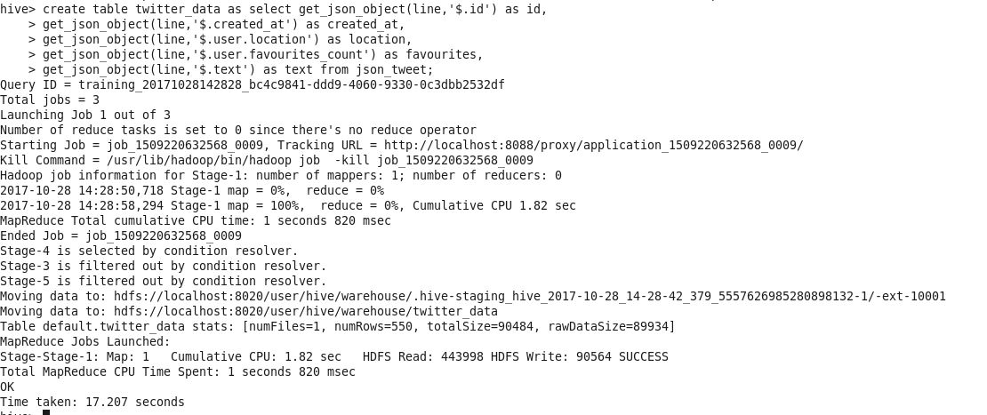

**1(b)** What is the most trending hashtag in a day and how many times are they tweeted? [Note: day should be in the format ‘yyyy-mm-dd’]

**Steps:**

1. Create a table “day_tweet” with tweeted text and tweet date, as required.

***Create table day_tweet as select cast(to_date(from_unixtime(unix_timestamp(created_at,”EEE MMM dd HH:mm:ss zzz yyyy”))) as date) as day, text from twitter_data;***

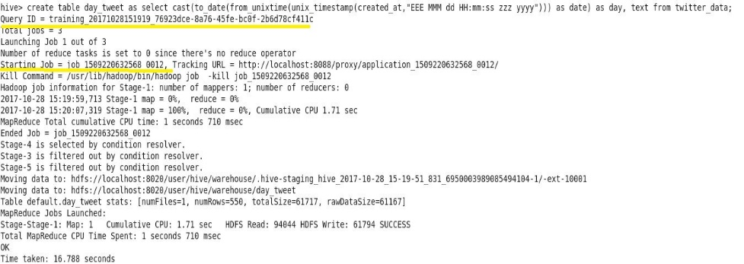

**Output:**

***Select * from day_tweet limit 5;***

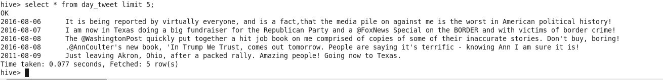

2. Create table – “day_hashtags” that has hashtagged words. However, there are a few hashtags that are without a space. Therefore, we have another table – “day_hashtags_split” that has our final list of words along with created dates.

**“day_hashtags” – table creation**

***Create table day_hashtags as select day, words from day_tweet LATERAL VIEW explode(split(text,’ ‘)) dayTable AS words where words RLIKE ‘^#’;***

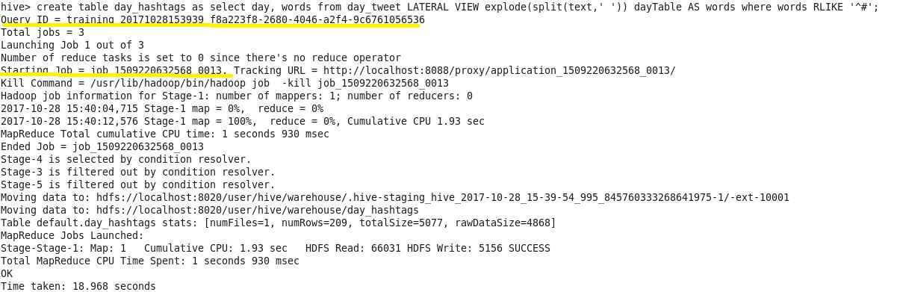

**“day_hashtags_split” – table creation**

***Create table day_hashtags_split as select day, tags from day_hashtags LATERAL VIEW explode(split(words,’# ‘)) dayTable2 AS tags;***

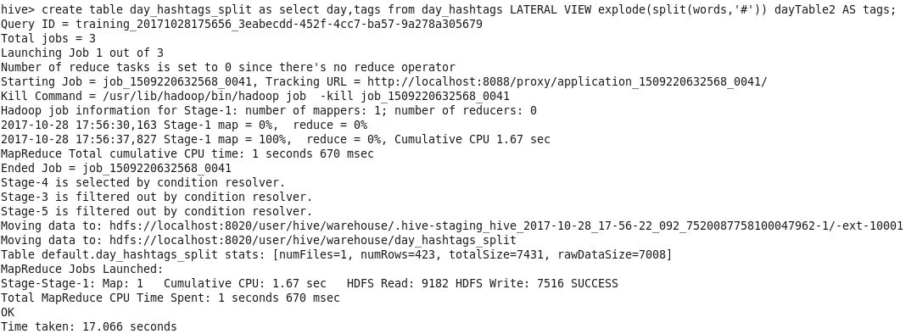

3. We have a table that consists of hashtag, created day and a column which gives count of a unique day and hashtag combination. – “day_trending”

***Create table day_trending as select day,tags,count(tags) as count from day_hashtags_split where length(tags)>0 group by day,tags;***

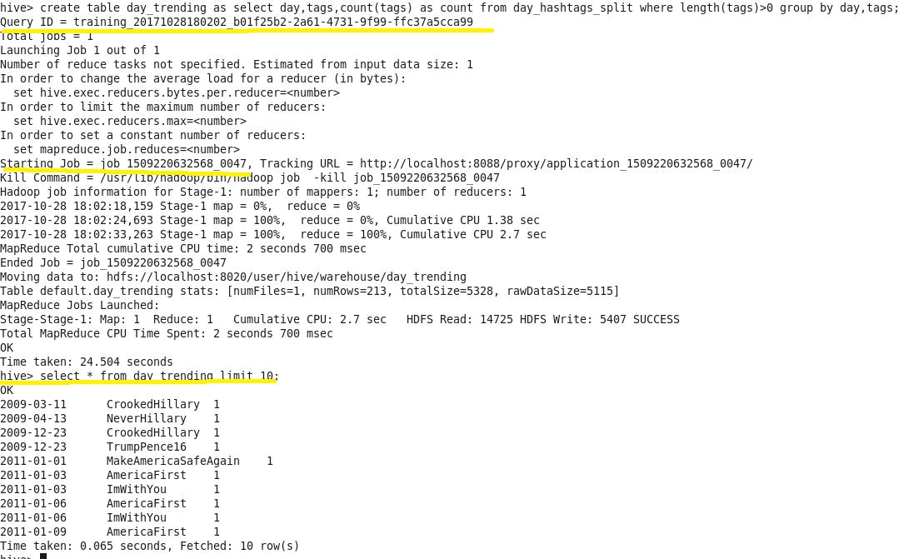

**\*\* we have same word repeated in a day on “2011-09-20”. Except for this date, other dates have a hashtag tweeted only once. (see screenshot below)**

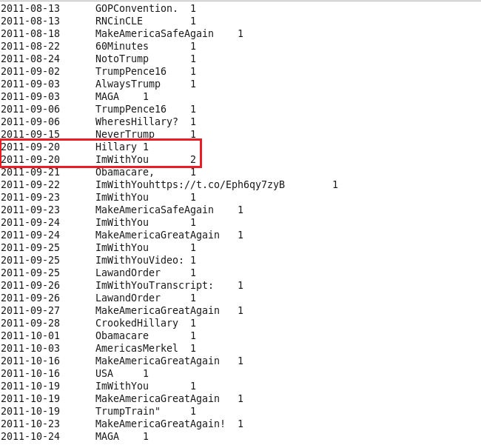

4. Finally, we need to get a hashtag, which trends most for a day. As far as data is concerned, the combination of day and a hashtag is repeated mostly, once. Therefore, most of the result has “1” as count of most trended word. And, each day has more than one trending word.

Now, create a final result table – “result_1B” that has hashtags, day and trending word for the day(count column)

***Create table result_1B as select d1.* from day_trending d1 where d1.count IN(select max(d2.count) as count from day_trending d2 where d2.day=d1.day);***

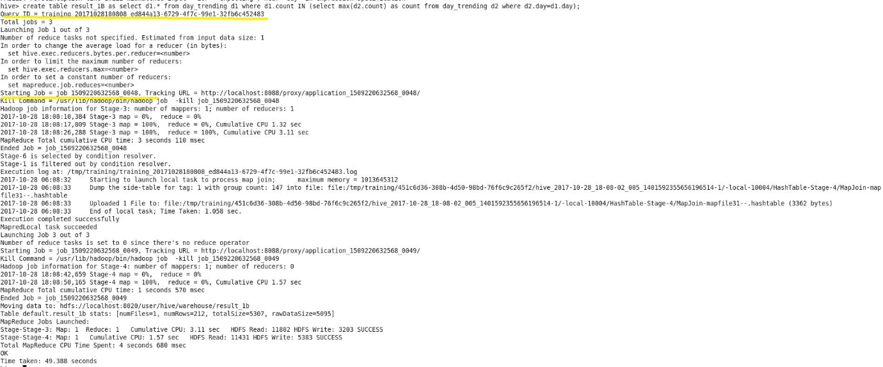

**Output:**

***Select * from result_1B;***

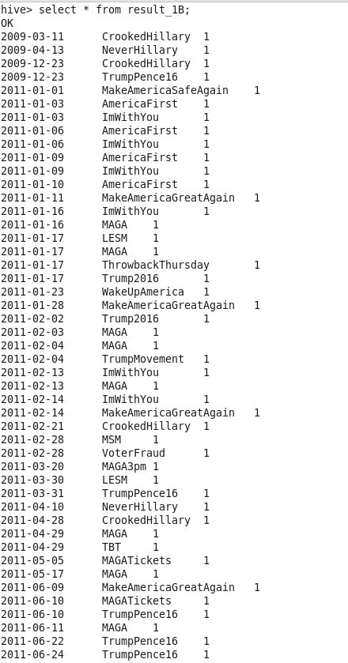 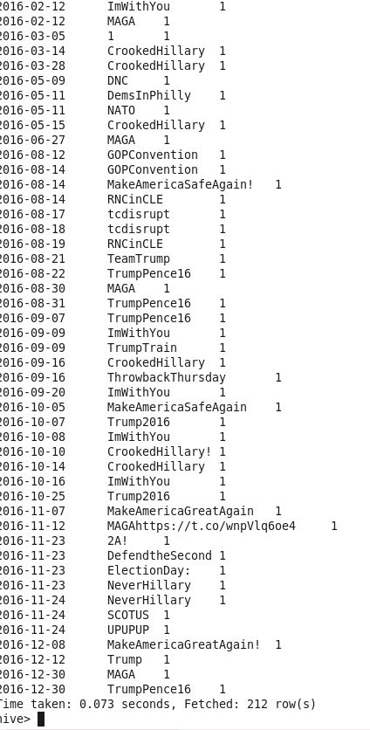

**\*\* now we can see that the date “2011-09-20” has only the hashtag that is repeated most/trended most.**

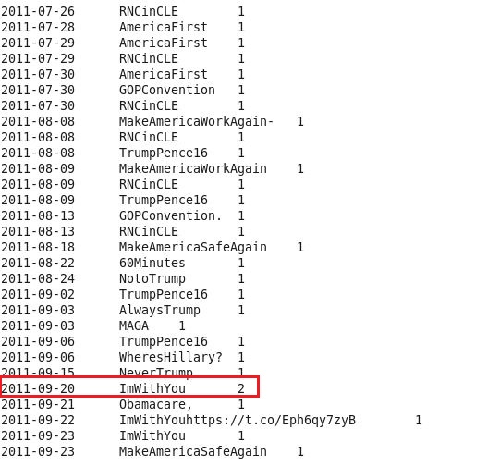

**1(C)** Which state users are most active, and how many tweets are posted by them?

**Steps:**

1. **User activity** is known by the **number of tweets tweeted by them**. Similarly, to find the state that is most active, we extract “location and count(text)” that helps to answer the question.

***Select location, count(text) as number_of_tweets from twitter_data group by location sort by number_of_tweets DESC;***

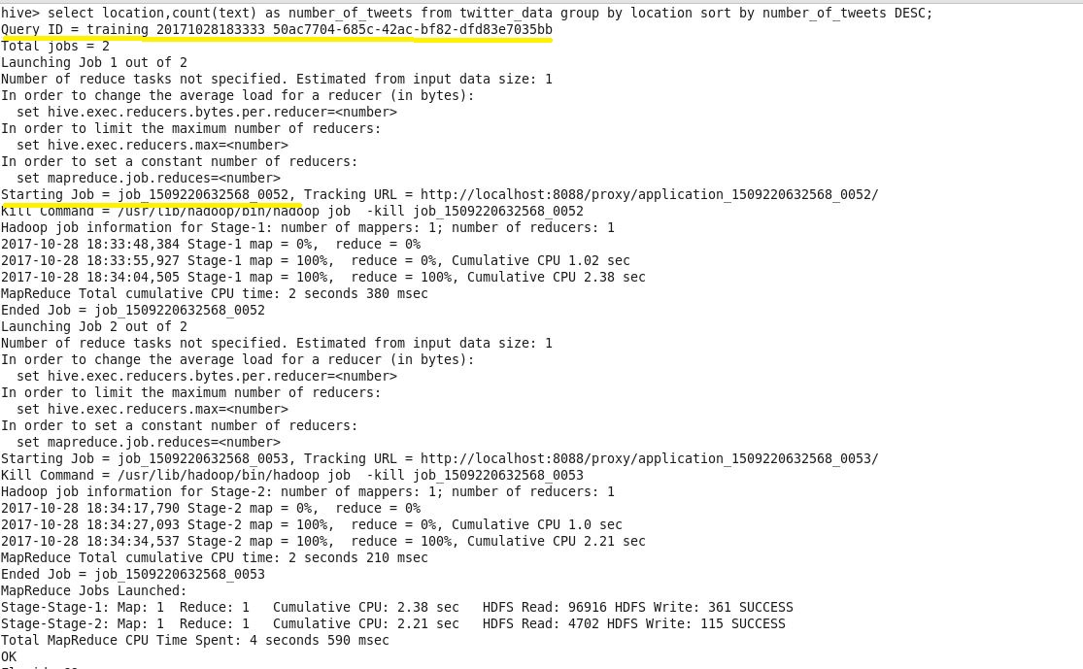

**Output:**

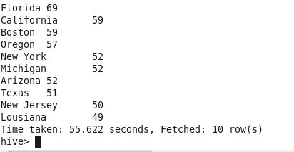

** Users of **“Florida” state** are most active, and they have posted **69 tweets**.

**1(d)** What is the total number of favourites received for each hashtag?

**Steps:**

1. We extra hashtags and count favourites with respect to them.

Initially, get text (in words format) and favourites in to a table – “tweet_fav”

***Create table tweet_fav as select words,favourites from twitter_data LATERAL VIEW explode(split(text,’ ‘)) table1 AS words where words RLIKE ‘^#’;***

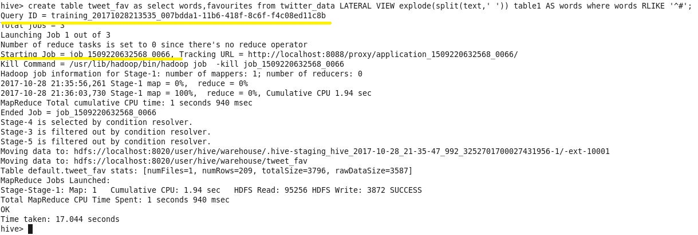

1. Since we have a few hashtags without space, we split the selected words based on’#’, now.

These words with favourites are saved in a table – ‘tweet_fav_hashtags’

***Create table tweet_fav_hashtags as select tags,favourites from tweet_fav LATERAL VIEW explode(split(words,’#’)) table2 AS tags where length(tags)>0;***

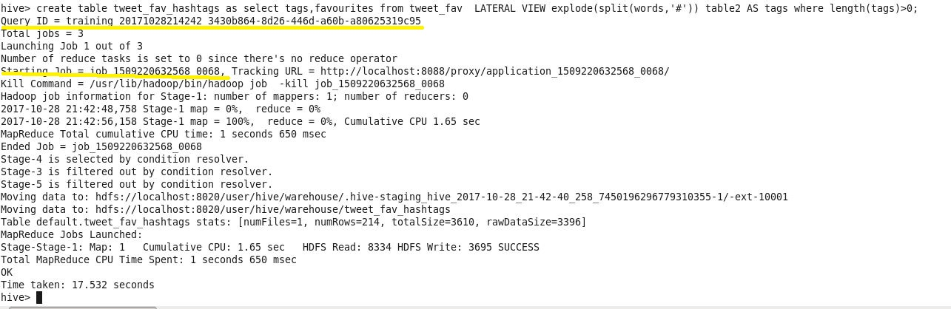

1. Finally, we can retrieve hashtag and its favourite count using the following:

***Select tags, sum(favourites) as total_favourites from tweet_fav_hashtags group by tags;***

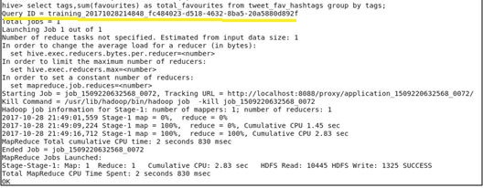

**Output:**

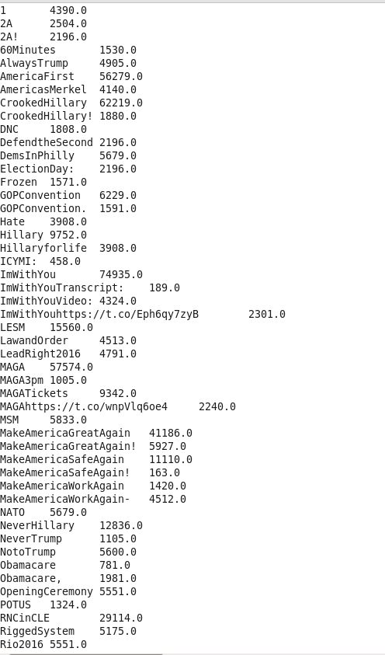 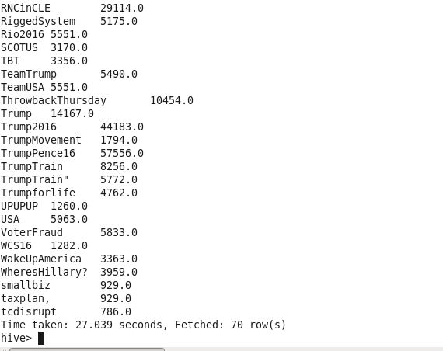

**1(e)** Does each tweet have a positive or negative sentiment?

Note: Include the date in the format ’yyyy-mm-dd’, with tweet id, user name and the score.

**Steps:**

1. Initially, create a dictionary table and load dictionary data in to it – “dictionary”

***Create table dictionary(words string, score int);***

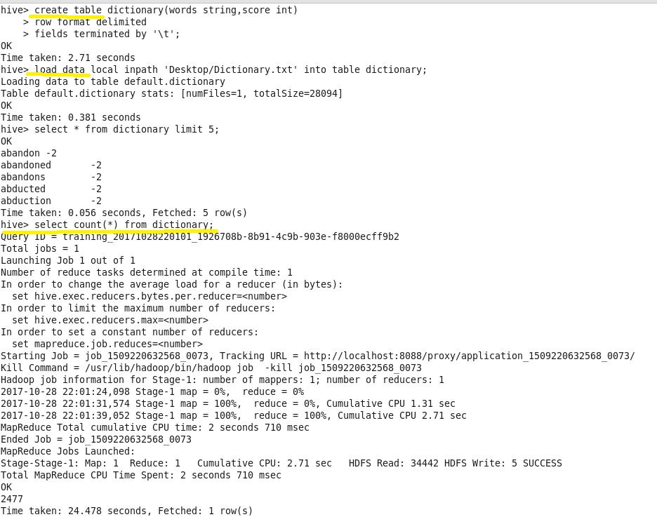

2. Create a table “tweet_score” that has the required fields (text, created_at, tweet_id, user_name) from twitter data file.

***Create table tweet_score as select get_json_object(line,’$.id’) as tweet_id, get_json_object(line,’$.user.name’) as user_name, get_json_object(line,’$.text’) as text, cast(to_date(from_unixtime(unix_timestamp(get_json_object(line,’$.created_at’),”EEE MMM dd HH:mm:ss zzz yyyy”))) as date) as dt from json_tweet;***

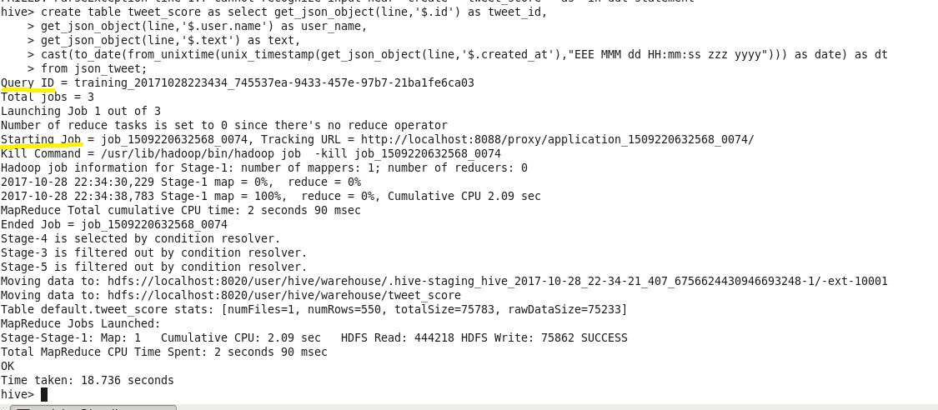

**Output:**

***Select * from tweet_score limit 5;***

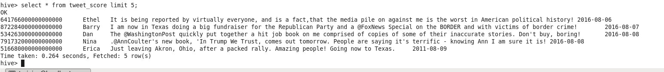

3. Create a table “tweet_words_Score” that has text in form of words, along with other required fields.

***Create table tweet_words_score as select tweet_id,user_name,dt,word from tweet_score LATERAL VIEW explode(split(text,’ ‘)) scoreTable AS word;***

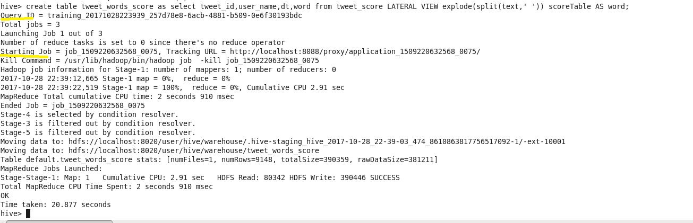

4. Create a table “dict_tweet” that culminates twitter data with that of dictionary data. This helps us to obtain a score of each word, which is obtained in step-3.

***Create table dict_tweet as select t.tweet_id,t.user_name,t.dt,t.word,d.score from tweet_words_score t left outer join dictionary d on (t.word=d.words);***

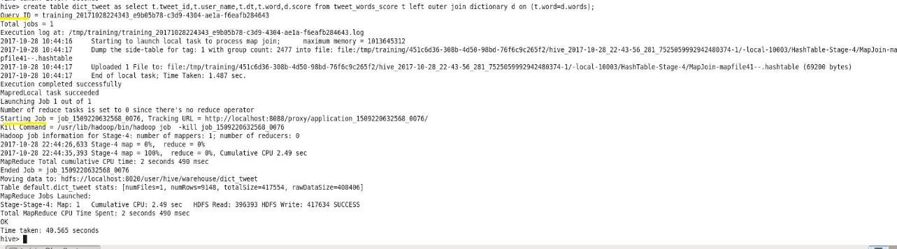

**Output:**

***Select * from dict_tweet;***

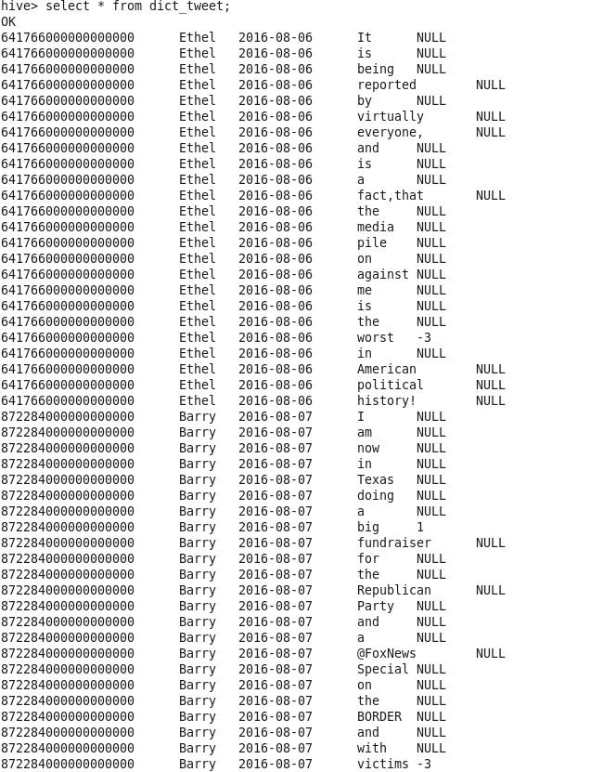 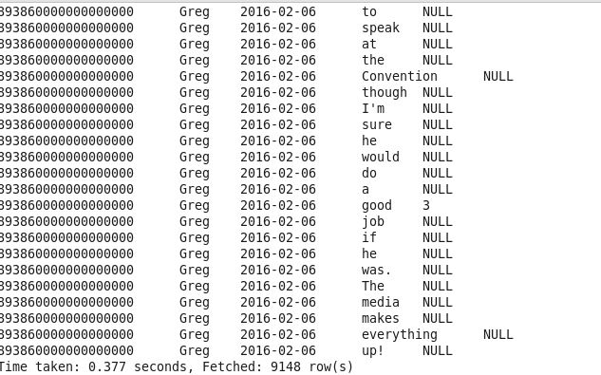

5. In order to obtain score of each tweet, we need to find score of each word and perform a aggregation on the words of text.

**Score of words – step4**

Score of tweet is found as follows: (table – “dic_tweet_score”)

***Create table dict_tweet_score as select tweet_id,user_name,dt,avg(score) as score from dict_tweet group by tweet_id,user_name,dt;***

***\*\* average or sum could be used. Either of them will give us same call/insight(sentiment score analysis)***

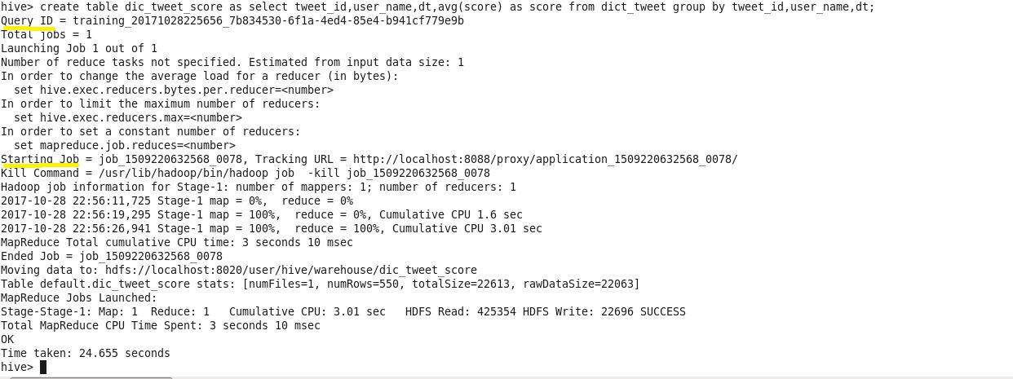

6. Finally, we associate positive or negative sentiment to tweets, as follows. (table – “tweet_sentiment”)

***Create table tweet_sentiment as select tweet_id,user_name,dt,score, case***

***When score>0 then ‘positive’***

***When score<0 then ‘negative’***

***else ‘none’***

***end as sentiment from dict_tweet_score;***

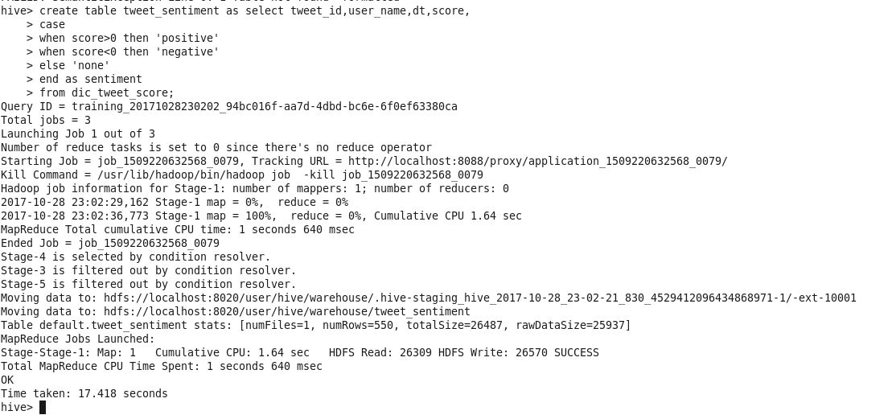

**Output:**

***Select * from tweet_sentiment;***

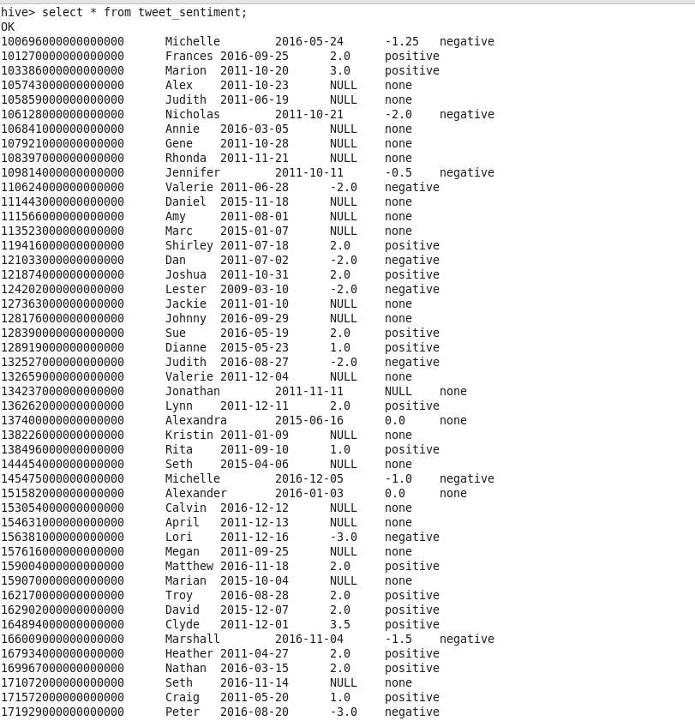 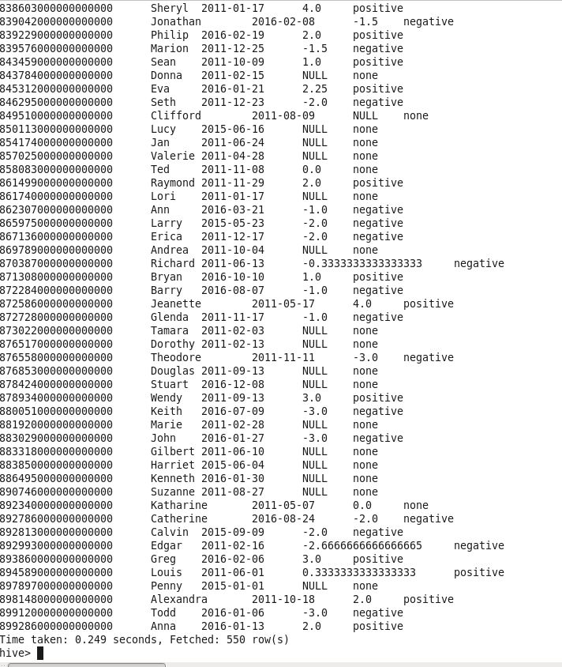

**1(f)** Do you believe that the process outlined above has issues? If so, briefly explain how the process can be improved.

**Yes, I believe so.**

* **Firstly,** the dictionary file does not have considerable/required words to associate appropriate sentiment to each tweet.
* There are many words in a tweet that are not mapped in the dictionary of words. Therefore, such words have a “None” sentiment associated with them. This has an impact on entire tweet sentiment, while we find average score value of a tweet.
* As **success of analysis lies in the data**, to get hold of this (above mentioned) issue**, the dictionary file needs to have extensive set of words.**
* **Next,** the words are associated a score based on what they mean in general sense. However, these words might have a different meaning in the content. **Hence, the score of the word needs to be contextual rather than generic. Since correlation is never a causation, one needs to have data and make a granular contextual analysis to get solutions/results.**
* For example, “prevent” has got negative score. However, it could have a positive meaning in a situation – “prevents fever”. Further, “playful” might have negative meaning, but the dictionary file has given a positive score to it.
* Similarly, **the word “not” has not got any score.**

Word obscene has got negative score. Usage of “not obscene” will make the meaning/sense positive. But, as there is no score associated with “not”, the negative score obscene has a clearly, big impact on a tweet. This could be overcomed for a better and realistic analysis.

**Screenshots:**

  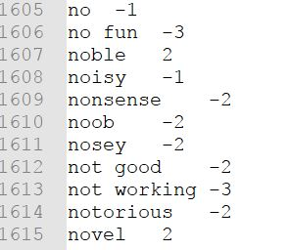

2. Twitter data comprises data types that are hard to handle at times. Using the same twitter data, display all the rows with the following columns: entity Id, entity screen_name, Text, Date, user location, date.

**Steps:**

* As the twitter data is stored in “json_tweet” table, we make use of the same to retrieve our required data. The result is stored in a table named “result_2”

***Create table result_2 as select get_json_object(line,’$.entities.user_mentions.id’) as entry_id, get_json_object(line,’$.entities.user_mentions.screen_name’) as entity_screen_name, get_json_object(line,’$.text’) as Text, get_json_object(line,’$.user.location’) as location, cast(to_date(from_unixtime(unix_timestamp(get_json_object(line,’$.created_at’),”EEE MMM dd HH:mm:ss zzz yyyy”))) as date) as Date_tweet from json_tweet;***

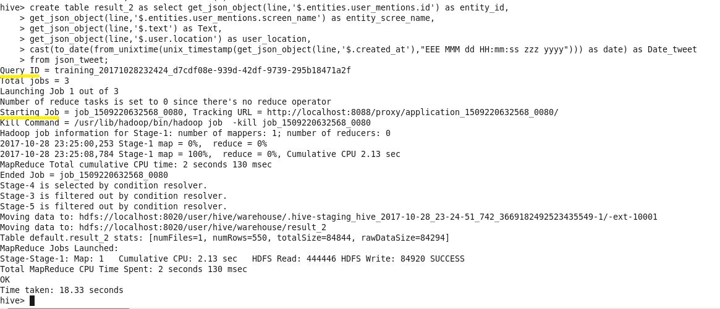

**Output:** For example, Output of the above is limited to 40 rows

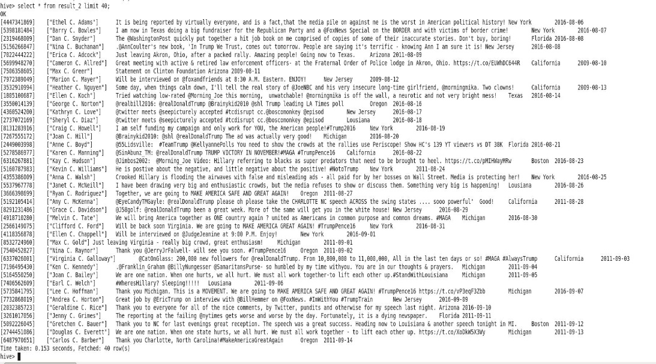

**NOTE:**

By using the following setting in hive,

**set hive.cli.print.header=true**;

We can have column names displayed, along with the data(rows).